**COVID-19 Response + Recovery Funding:**

**Dashboard Development for COVID-19 Manufacturing Capabilities within El Paso Community**

1. **Problem Statement**

The COVID-19 pandemic caused acute shortages for personal protective equipment (PPE) nationwide and, ordering these PPEs from the national stockpile has been practically difficult, due to demands from hospitals or due to the products’ expiry date. According to the El Paso Department of Public health, the number of cases for COVID-19 patients are increasing (Figure 1). So, when the El Paso community is being hit by the COVID-19 pandemic, business and administrators scrambled to acquire PPEs or contact manufacturers who can manufacture PPEs to placate the city’s demand. Moreover, Governor Gregg Abbott has accepted the request from El Paso County Judge Ricardo Samaniego, county commissioners, and other elected officials to exempt El Paso from early business openings. This exemption can have dire consequences to the businesses in El Paso nevertheless community’s health is of utmost important and depicts the impact of pandemic on local businesses.

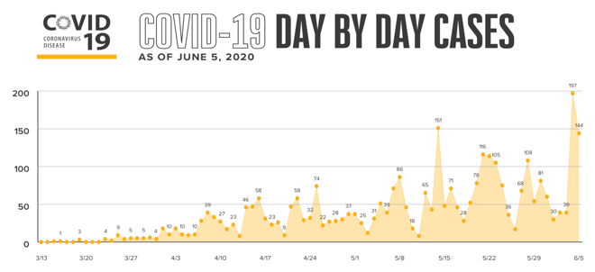

Figure 1: COVID-19 day by day cases from epstrong.org

El Paso’s economic development office and chamber of commerce can help the business community to support each other during this time of pandemic. Currently, the activities include a website ([www.elpasobusinesshelp.com](http://www.elpasobusinesshelp.com)), a Facebook public group titled “El Paso Businesses Stand Together” (<https://www.facebook.com/groups/1375488742630083/>), and newsletter from the El Paso Chamber of Commerce. This supporting infrastructure can be enhanced using a dashboard for manufacturing capabilities of El Paso and calls for creating a centralized information source for stakeholders, businesses, and communities to identify and locate local manufacturers who can adapt their facilities to produce PPEs required for the community.

El Paso’s manufacturing capabilities encompass diverse sectors such as textiles, automotive, biomedical, defense, electronics manufacturing, and shipping and warehouses. For supporting the COVID-19 pandemic, El Paso also has medical suppliers, medical device manufacturers, pharmaceutical companies, soap and other disinfectant companies, and other plastic, rubber and other materials manufacturers.

1. **Outcomes**

In this project, we propose to develop a dashboard to depict the manufacturing capabilities of El Paso and nearby areas to help the local business owners get information to restart their businesses safely and successfully. This dashboard will act as a one-stop shop for all industries who wants to adapt their facilities to support the communities to prepare for the pandemic’s adverse impacts. A sample dashboard is shown in Figure 2 that shows various sectors in El Paso and near by cities and their average revenue. Their geolocation is also provided to understand the logistics requirements. Moreover, such an interactive dashboard developed as per the requirements of the users (stakeholder, business owners, government officials), can help these users select on the manufacturing capabilities of El Paso that can positively impact the local businesses and reduce excessive bombardment of information.

**El Paso Manufacturing Capability Dashboard**

Figure 2: A illustration of a potential dashboard

The dashboards performance can be calculated based on the amount of information available to the local businesses, number of accesses to these information, and user feedback on the usability of these dashboard. The long-term stabilization outcome comes from the impact on business to help each other utilize their capabilities to improve each other’s businesses. In long term, this database can be expanded for the economic development activities of the community. For example, recently, El Paso’s Mayor sent an invitation letter to Tesla to build their manufacturing plant in El Paso. We can use the information from these dashboard to showcase Tesla on various capabilities of El Paso community and what advantages it can provide to Tesla if they move to El Paso.

1. **Methods + Outputs**

We use a geolocation based information for providing statistics to the local businesses to utilize such information to make data-driven informed decision making. Data driven business decision making is used by large as well as small businesses around the world to improve the operations and reduce inefficiencies. As Industrial engineers, the IMSE department at UTEP, can develop such decision support infrastructure for the local manufacturers to adapt to the communities demand from local businesses. We also can leverage the TMAC expertise to provide necessary counsel to improve and adapt their capabilities in the most economical way.

We will meet with the stakeholders and business leaders to understand their requirement on acquiring products to conduct the business safely. We will also leverage the TMACs contacts with various manufacturing plants in El Paso to provide an updated list of capabilities. We will then create a dashboard that can provide these information in a user friendly way that avoid clutter of data.

The research center, RIMES, within the Industrial Manufacturing and Systems Engineering (IMSE) Department at UTEP is a premier research institute focusing on research of new knowledge and its application in manufacturing and engineering systems. RIMES house the Texas Manufacturing Assistance Center (TMAC), a manufacturing consulting center, that delivers hands-on business management, technology and operations solutions to a wide range of businesses, including manufacturing, distribution, logistics, construction, health care and government. With extensive experts in industrial and systems engineering, the Principal investigators deals with the processes of improving, implementing and evaluating systems that include people, money, machines, information, energy, and materials. Moreover, TMAC works with an extensive network of manufacturers in Texas and can leverage this contact to develop the database of manufacturers as well as their capabilities. Our research center has also been collaborating with various organizations such as the Medical Center of the Americas, Bio El Paso Juárez, Workforce Solutions Borderplex, New Mexico Manufacturing Extension Partnership (MEP) and the El Paso Hispanic Chamber of Commerce.

The dashboard that is developed as part of this project can be accessed by all businesses and can be linked to the El Paso’s governments website.

1. **Evaluation Plan**

The dashboards performance can be calculated based on the amount of information available to the local businesses, number of accesses to these information, and user feedback on the usability of these dashboard. These information can be easily collected from a web interface as well as using customer surveys on how this information has helped the businesses to restart safely. The questionnaire can be an online survey sent to the users as well as stakeholders.